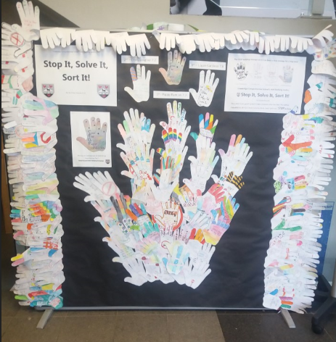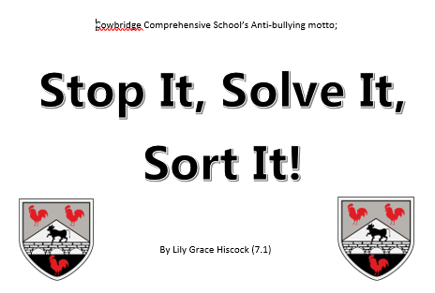
The Anti Bullying Committee, who are trained as anti-bullying mentors, work with the students and staff in Cowbridge School to try to combat bullying. We aim to educate students about bullying and increase awareness of what to do if they are bullied and to guide them to what support is available.
We have previously held bake sales to raise money for Bullies Out, who we work with to train new members of the committee on bullying, its effects and its prevention. Additionally, we have, and continue to hold workshops, within PSE lessons for the younger students of the school, specifically last year we ran workshops with the Year 7s on cyber bullying, an area we feel is a priority due to the rising use of social media. The aim of these workshops is to work closely with the younger students to reinforce the message that bullying is not tolerated in the school and to educate about cyber bullying and how to use social media safely.
Each year we help out during the Year 6 transition days to introduce the committee and discuss bullying within the school, specifically how it is not tolerated, what to do if you experience bullying and what bullying is. This helps build a link between the committee and the younger years. We feel it is important to start the conversation about bullying early on to help prevent it later in school. Assemblies are a big part of our work within the school, as they allow us to engage with each year group and discuss issues regarding bullying specific to the year group. Throughout the school, we have displays and posters that regularly remind pupils of how to get help for bullying and what counts as bullying. Often these displays include mottos, messages and drawings done by students in the workshops we run. This year in the Year 6 transition day, we held a competition for the students to design a hand to help represent the committee and our message. A handful of the entries are currently displayed in the A block foyer. The motto for the committee was also created by a student, Lily Grace Hiscock, ‘Stop it, Solve it, Sort it’, who won the competition. We have found that our work with the younger years has had an effect on bullying, as since the committee has started working closely with younger years, there has been a decline in incidences of bullying within the lower year groups.
