**Disability Awareness Week 2020 at CCS** 

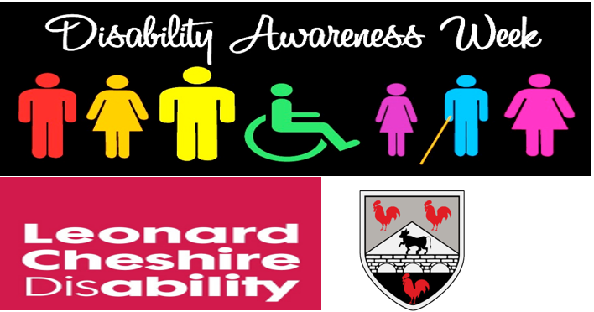 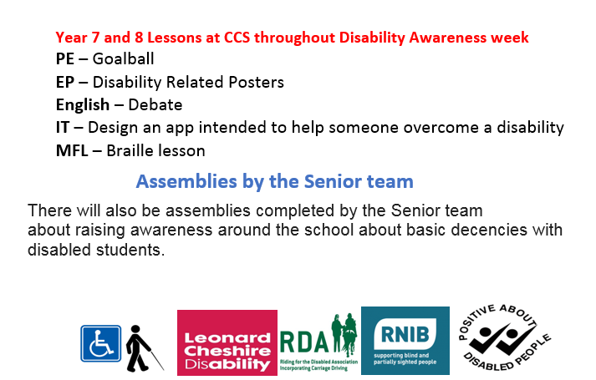

**Year 7 PE lesson on Goalball with Mr Thomas**

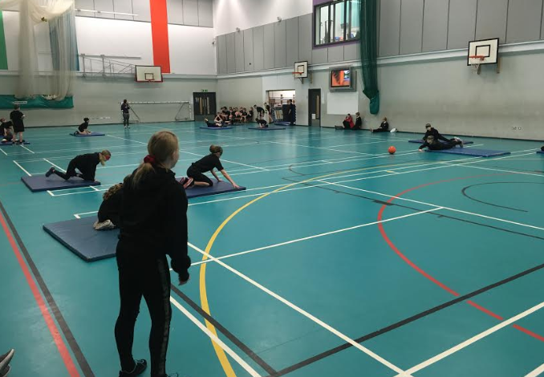

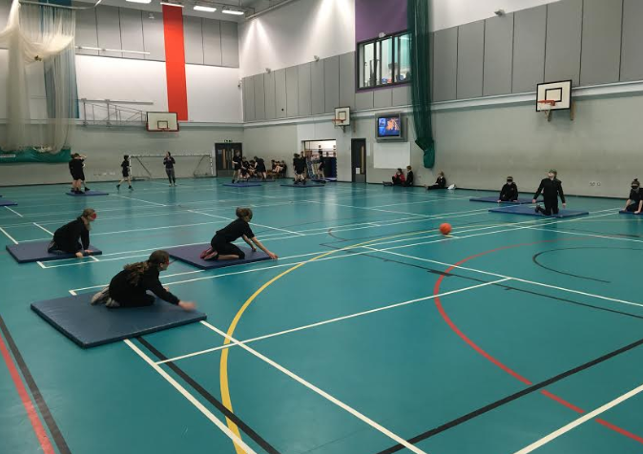



**We raised £40 for the charities ☺**

Winning Posters from EP.

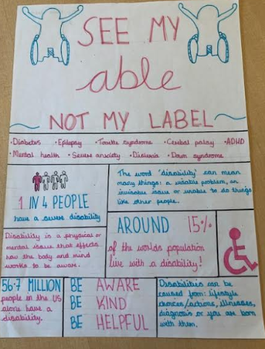 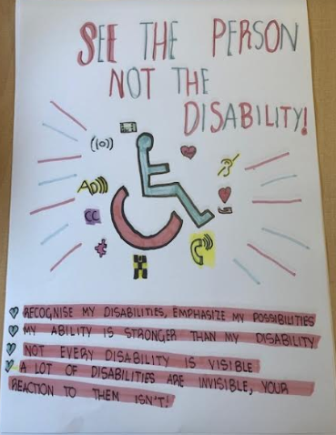 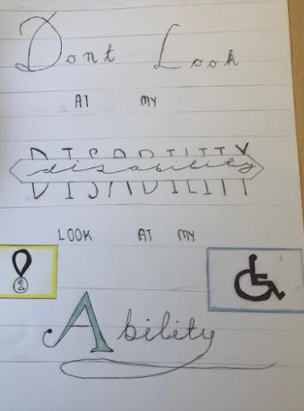

Aimee Hatch 7.1 1st Mkayla and Emily 7.4 2nd Grace Davies 7.7 3rd