

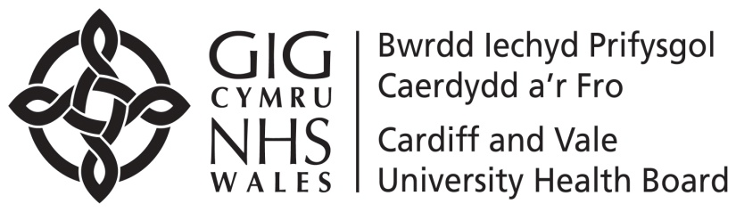

September 2023

**Help keep your child well this winter – make sure they have their flu vaccine.**

Dear parent or guardian,

The school nursing/immunisation team will visit school on 25/09/2023 to offer children a **nasal spray flu vaccine**. The NHS recommends all eligible children should have a flu vaccination every year. Please read the attached information.

The cut off for submission of the E- consent is the 22/09/23(10am) Any consents submitted after this date will be offered catch up clinic appointments. Please use the link below or scan the QR code with the camera on your mobile phone to access the E-Consent Form - please complete even if you do not wish you child to receive the vaccination. Once you have opened the consent form, click the tab at the top of the page to choose to complete the form in Welsh or English.

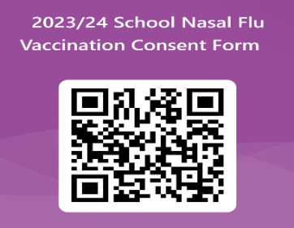

<https://forms.office.com/e/gZB4DgXvuq>

It’s very important to protect your child from flu to make sure they stay as healthy as possible, as both COVID-19 and flu are likely to circulate this winter.

The best flu vaccine for most children is a nasal spray. This is the vaccine that will be given on the day.

If you want more information about flu vaccination for children, please contact the School Immunisation Team, or phone NHS **111** Wales or visit **[phw.nhs.wales/fluvaccine](http://phw.nhs.wales/fluvaccine).** Please keep this letter as it contains the date of the vaccination session and contact details.

 Yours sincerely,

**School Nursing Immunisation Team**

**After you have returned the consent form, please contact the School Immunisation Team on 02920 907661/664 or Immunisation.Cavuhbschoolnursing@wales.nhs.uk before the vaccination session if:**

* **there are any changes to your child’s health, or**
* **their asthma medication is increased, or**
* **they are prescribed oral steroids, or**
* **they become wheezy.**

Note: There are a very small number of children who should not have the nasal flu vaccine please see the information sheet for more detail, or look at [**phw.nhs.wales/fluvaccine**](http://phw.nhs.wales/fluvaccine).

