Human Rights Week at Cowbridge Comprehensive School December 2018
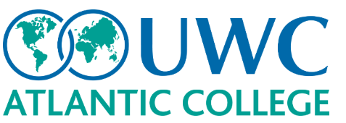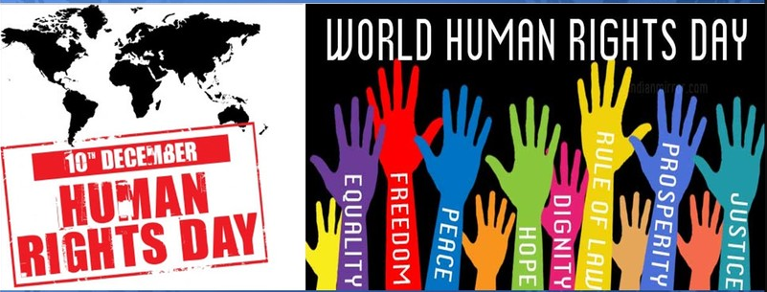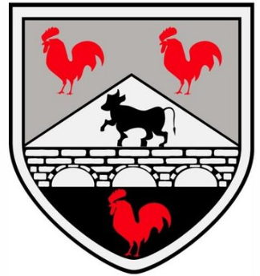
Sixth form students at Cowbridge Comprehensive School recently organised a series of activities to mark Human Rights Day which is celebrated on 10th December. Presentations were given in assembly and discussions took place with groups of students of all ages. Pupils learnt about the history of Human Rights Day which was first adopted by the General Assembly of the UN in 1948. It is accepted that the UDHR is one of the UN’s most important achievements.
To help pupils’ understanding of the Articles agreed and incorporated into the UDHR, the school welcomed four students who were studying at UWC Atlantic College at St Donat’s in Llantwit Major. Atlantic College has 360 students from over 80 different countries. The four who visited Cowbridge were Banke from Nigeria, Andrea (Italy), Camila (Bolivia) and Asel (a Palestinian who is living in Israel). This offered a great opportunity for students in Cowbridge to hear about the issues that affect the people living in those countries.
Students were told about the discrimination against minority groups that exists in relatively prosperous countries like Italy which has had to deal with refugees fleeing countries in North Africa and the Middle East. People in Nigeria, where the population is divided between Christian and Muslim faiths, have faced religious persecution. Healthcare is not freely available in Bolivia and although Palestinians make up 20% of the population of Israel, they face discrimination and prejudice.
Students asked many questions of the visitors which certainly gave a different perspective to the issues that were being debated in school. Everyone agreed that it had been an absorbing discussion and we hope to be able to develop closer links with Atlantic College in the future. Thanks must go to Mrs Taylor-John and also Sian Hughes of Atlantic College for arranging this very enlightening visit.
Mr Martin Blamey

