\School Council meeting agenda 14th March 2024- Disability Awareness Workshop
The meeting will be led by the Head Boy and Head Girl.
- Welcome to our fourth School Council meeting for 2023-24 No minutes, as notes taken by SC Members on the workshop.
- Please note -The School Council process for all School Council Members to follow. This is the process for your Year Council meeting.
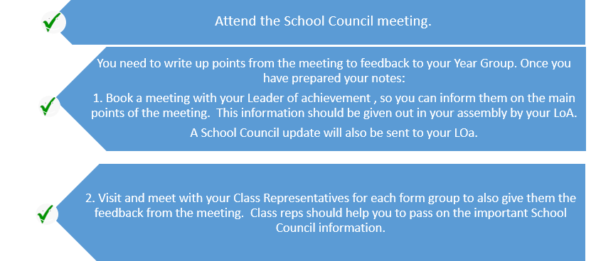
The points below should be discussed during the process above.
The main focus of today's meeting is attaining disability awareness information so you can inform your year group. Please also see the PPT’s on the email to help in this process.
- Suggestions- Please see list at end of agenda. These will be passed on to relevant staff members.
- Global Group/Concert- £700 raised for DEC Turkey /Syria
- ECO update- Recycling project ongoing in readiness for Global Recycling Day and April’s new laws. -Please display posters.
- School Newspaper - A spring version of the newspaper is on the way.
- Rotary update- Rotary boxes collected last Tuesday. Picture on Twitter. :)
- Lounge Project for year 7’s on going in week 2
- Make Your mark event completed. Over 1000 responses. Results sent to VOG.
- Cancer Charities raised £270 with the cake pops (Cancer research/Marie Curie) and Marie Curie daffodil total was…..
- Old School Uniform project to be considered.
- Youth Peace Ambassadors - School Council Members have applied AOB-................... Next SC Meeting 25th April 2024
Suggestions- school- Suggestions will be sent to relevant staff. /canteen
Own clothes days/non-school uniform days/More non-school uniform days as we haven’t had one in over a year./ feel like we need to do fundraisers or something that students will enjoy such as non school uniform days and maybe a sports day.
Shorts in the summer/pe kit when it gets hot/Shorts allowed in the summer
CANTEEN Please could you make school food cheaper as in M&S 4 blueberry muffins are £2 but in school one blueberry muffin is £2. Most teachers also agree with me because we shouldn't be worrying about going into debt at school. Every time I would like to buy something, I can't because the previous day I bought one muffin or a lunch and then I have all of a sudden got no money left. Please take this into consideration!
Improvement of canteen food and prices( healthy food options)
Canteen hot food
Canteen improvements
Make food nicer
I think we need more healthy foods in school because it really annoys me how I need to do pshe lessons on healthy eating but the only foods the school sells are pasta and pizza.
We need a place to do homework since the break out areas are out of bounds
Opening the main hall at lunch and break, opening downstairs toilets again due to the increase of wait time at the upstairs toilets./Can we have somewhere inside/warm we can go at break time and lunchtime?YEAR 11 BEING ALLOWED INSIDE TO REVISE!!!!
Teachers should be more aware of Bullies in class and should treat the male and female students the same
I think that the school should introduce an LGBTQIA+ club at lunchtimes for anyone who would like to understand and learn about their own sexuality or get to know other people like them across all school years.
A football club during lunch time on Thursdays/More after school clubs
BUSES-Make an s29 bus. There are too many Ewenny children on the Ogmore and St brides bus. It is too crowded and often some people can't get home on time. People often have too go on the s23 bus which takes an 1 hour and 15 minutes to get to Ewenny./Tell the year 10/11s to stop vaping at the back of the bus thank
make school longer by an hour and make the breaks longer Bring phones back pls

School Council Disability Awareness Workshop Agenda 2-3pm
Please make sure you have a workshop note sheet before the workshop starts. The notes you make will help you create a summary of feedback for your Year Group and Leader of Achievement to use in assembly or during form time. The focus is: If CS Students can attain an awareness of different disabilities, it will help them understand how they can help those with these types of disabilities at CS.
- Disability Awareness - PPT
- Talk on Autism (invisible)-Jacob and Ed (PPT on email- Autism Awareness/Acceptance Day 2024)
- Disability awareness at CS Q & A session (refer to PPT slide 7 How can CS students help those with disabilities at our school) - Mrs Huntley and students
- Basic Makaton lessons for all CS students to use (PPT on email BSL/Makaton)- Georgia Howes Head Girl
- Year 7 Poster Competition.

The key message to tell all students is-PLEASE BE DISABILITY AWARE, PLEASE BE KIND AND PLEASE BE POLITE.

